**MEETING MINUTES: SUMO DIGITAL GROUP PROJECT**

**Date of meeting:** 11/02/2019

**Time of meetin**g: 11:40 AM

**Attendees**: Dragos Liche, Dawid Hojka and Alex Butler

**Apologies from:** Anthony Skipwith

**Mid-sprint review:**

Most of the tasks we set out for the sprint were completed during the game jam session on Wendsday last week, and only few remained to be done over the remainder of the sprint (character design for Dawid and Alex, reticle movement research for Anthony and 3D mockup of the level by Dragos). Both character design tasks were completed by the time this meeting happened, and both the reticle movement research and 3D mockup are in-progress, so the overall progress is looking very good.

Since Anthony was not present on the meeting today, we are not exactly sure how confident he is with making the reticle system yet, and we may require help from one of the tutors on the next game jam session.

**Tasks that are yet to be completed:**

* **Dragos:** Finish the 3D mockup of the bar/city level, the game will take place in.
* **Dawid:**  *All tasks completed for now.*
* **Anthony:** Continue researching how the reticle movement system would work.
* **Alex:** *All tasks completed for now.*

**Meeting ended:** 12:10 PM

**Minute taker:** Dawid Hojka

**Discord Discussion Documentation:** 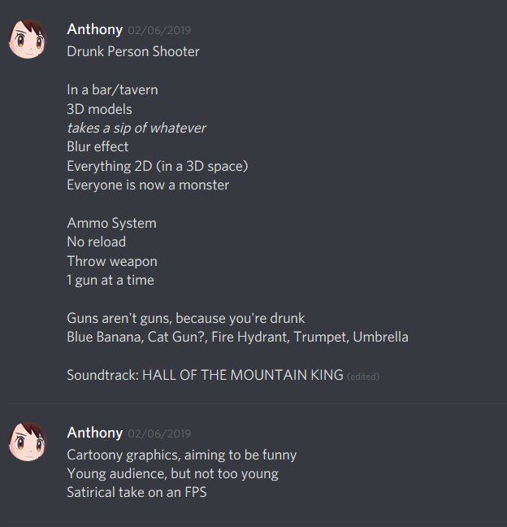

Screenshot - Anthony writing up the ideas we discussed during this meeting, so that we can use it for future reference.

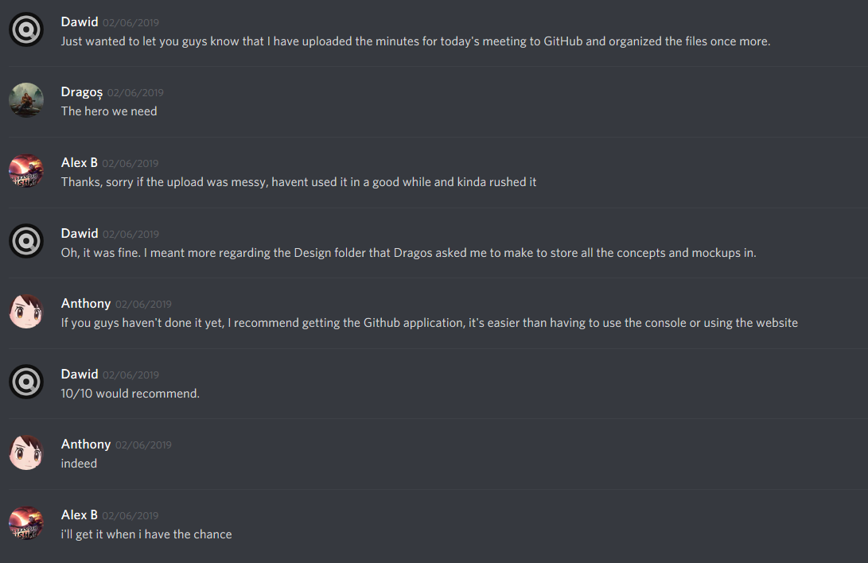

Screenshot - GitHub related discussion.

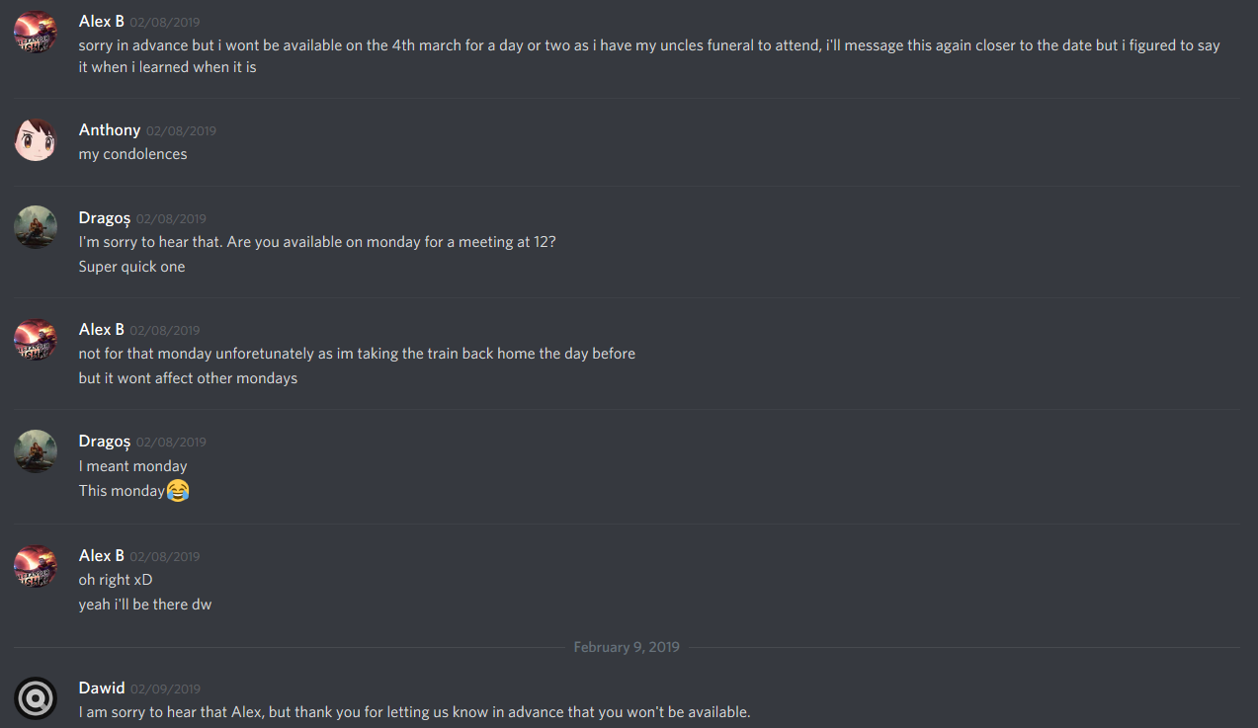

Screenshot - Alex letting us know in advance of his absence on March 4th.

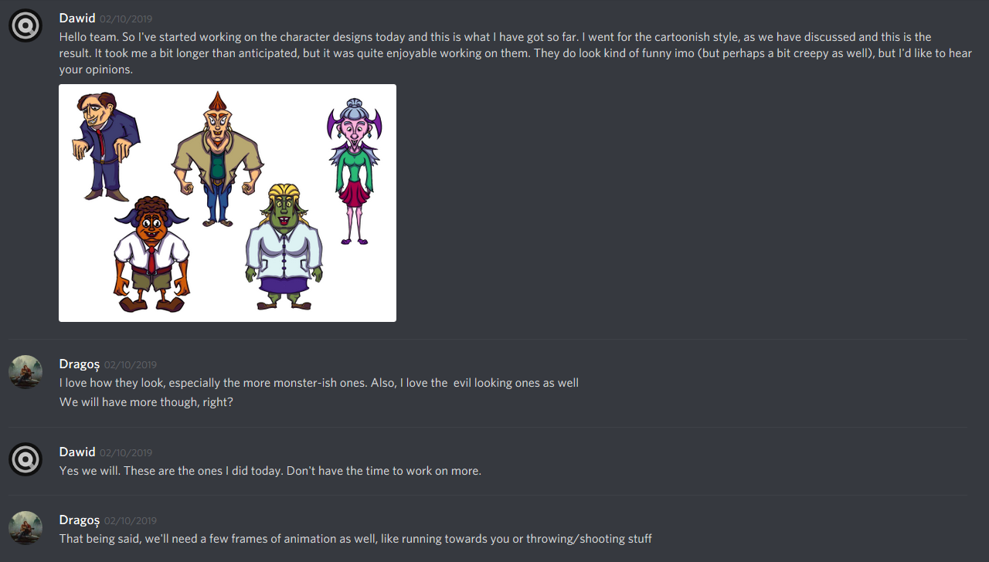 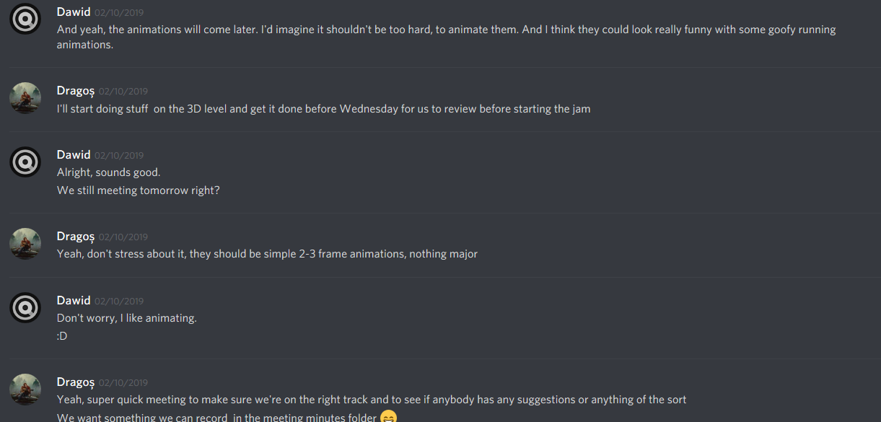

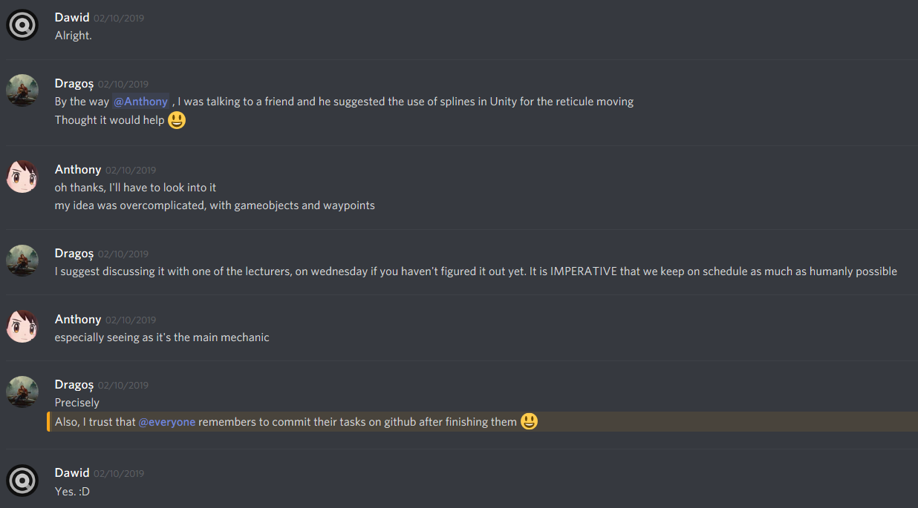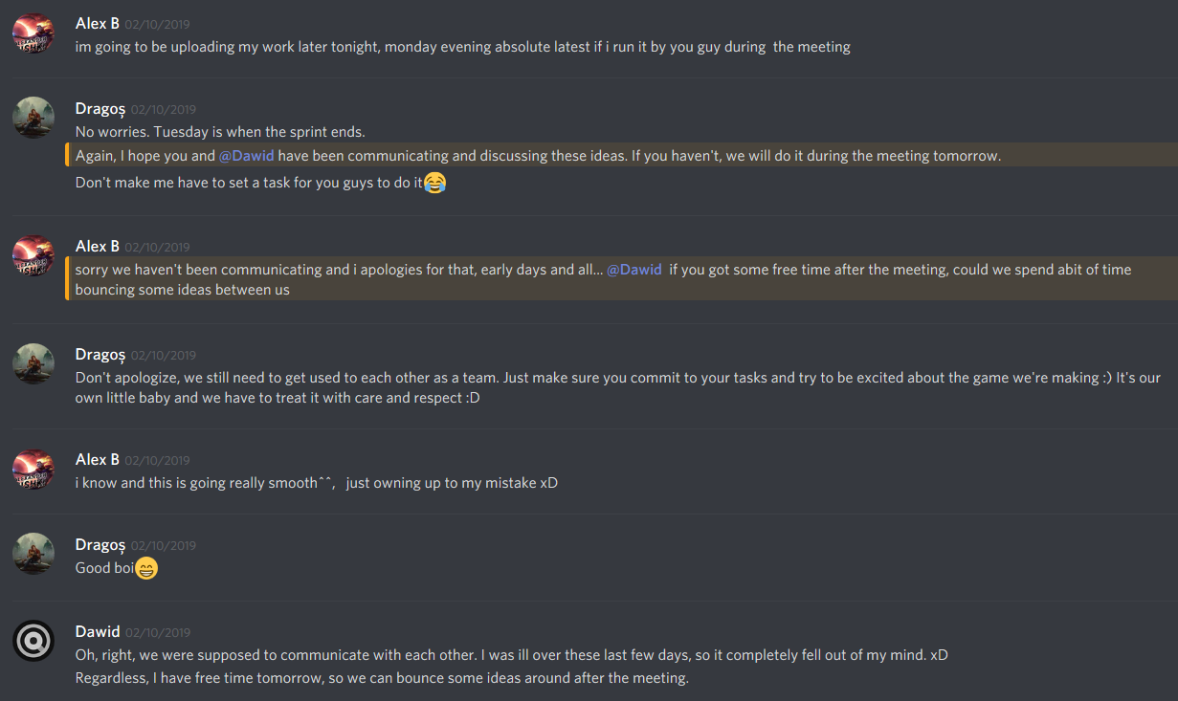 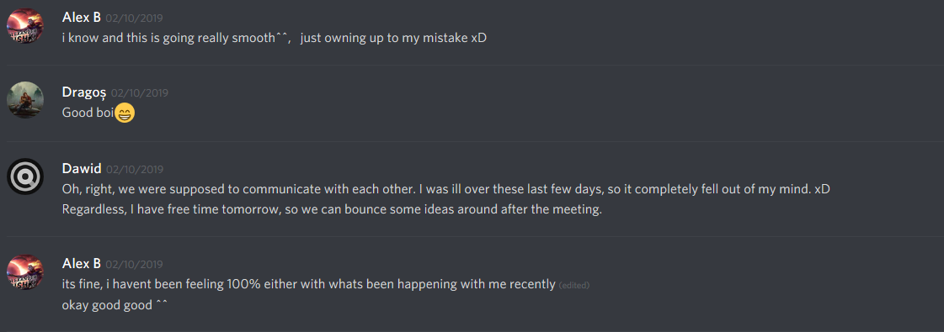

Screenshots - 8 - We were mainly discussing the tasks we have done over the weekend.

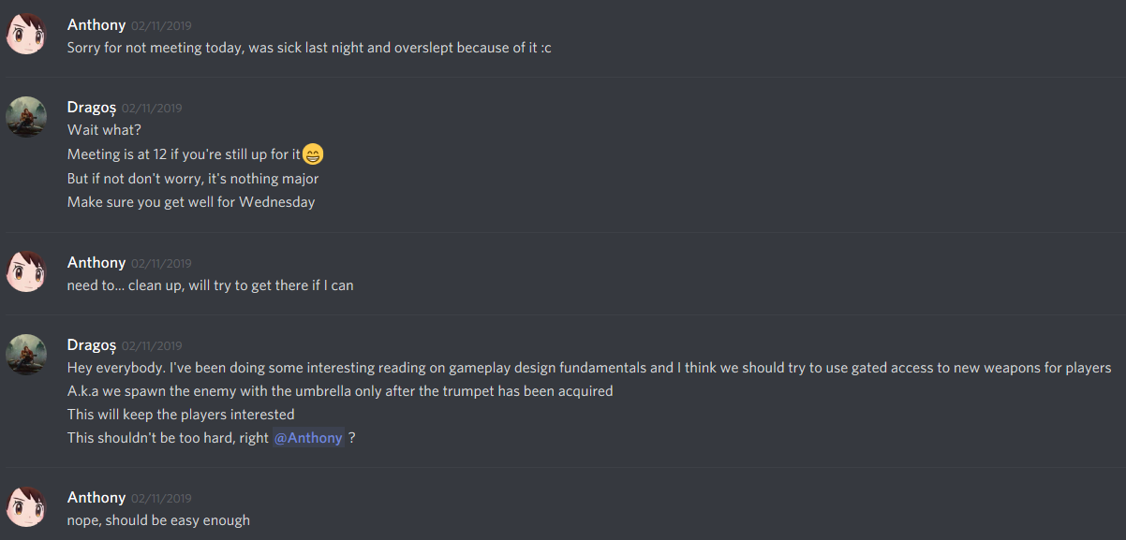 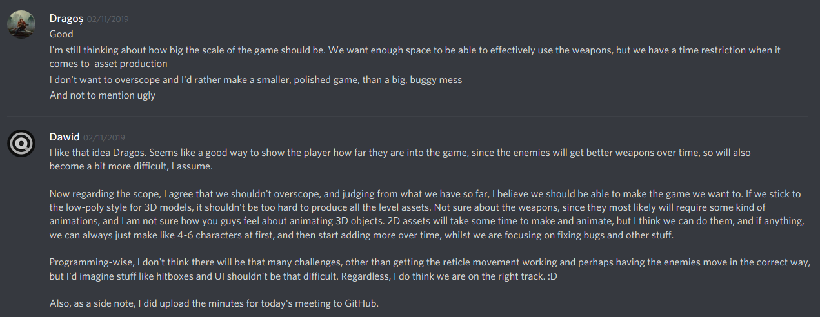

Screenshots 9 - 10 – Anthony letting us know he won’t be able to make it to the meeting, as well as Dragos proposing an idea.